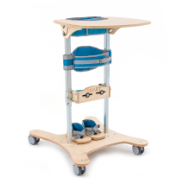
The Smart Active Standing Frame for Infants and young children.
- The Smart Active Stander gives the infant an early experience of standing. It is adjustable to enable the infant of 8 months and can be used up to the age of 4 years old for young pre-school child.
- The Smart Active Stander uses an innovative system UPRIGHT PROTM consisting of a chest strap and 2 pelvic braces with a wide variety of adjustment and flexibility that enables the young infant or child to adopt an upright position statically and dynamically as indicated.
- The Smart Active Standing Frame combines the advantages of being easy to lift, easy to use, has a robust design and has stability. Due to its simplicity the standing therapy is very comfortable to use.
- The Smart Active Stander is equipped with four braked swivel casters with brake that allow the young child to move indoors or outdoors on the flat.

The Smart Active Stander is recommended for the following conditions:

The Smart Active Stander is for children who have good head control and are developing trunk control

- Developmental Delay – Infants and young children with developmental delay of known or unknown origin e.g. genetic or metabolic conditions.
- Developing Posture and Movement Disorders with increased tone evident in lower limbs.
- Cerebral Palsy – Congenital and Acquired – Spastic Diplepia, Triplegia, Ataxia Hemiplegia.
- Acquired Brain Injury.
- Spina Bifida – T9 to S2.
- Neuromuscular Conditions.
- Rare Conditions: e.g Arthrogryphosis:

Accessories
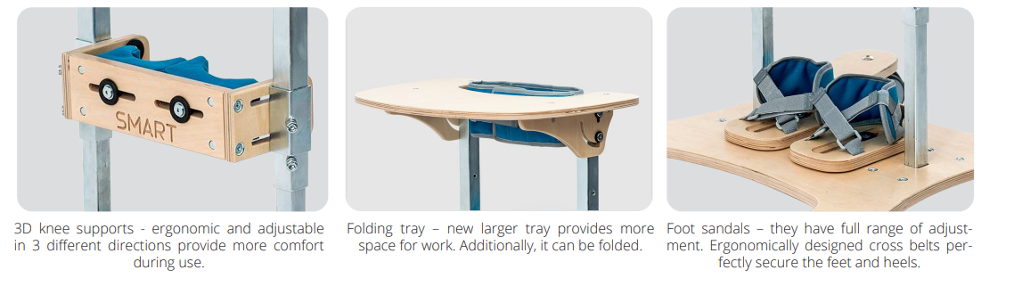
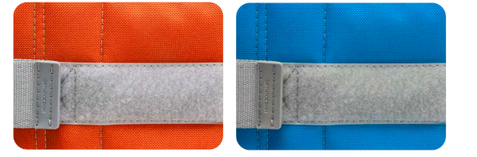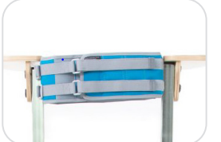

Red belt is flexible Blue belt is rigid Chest strap can be adjusted.

Therapeutic Advantages

The Smart Active Stander can be used for Targeted Training for infants from 8 months to children up to 4 years
- For the young infant who is under 50 cm in height (symbol C1 upwards) the tray can fold down to enable the stander to be used at a low table.
- For the young child that requires manual support at shoulder girdle level
The infant or young child’s functional level is at level of head. The tray supports the child’s arms to encourage play and improve upper trunk control using both the truncal brace and the rigid pelvic brace
- For the infant or young child with an active and reactive trunk the tray folds down to enable the child to strengthen their trunk and pelvis using the rigid or flexible pelvic belt depending on their ability.
References: Segmental Assessment of Trunk Control ( SATCo).

The Smart Active Stander is available in 2 sizes

Size 0a Children 8 months – 2 years, height 50 – 70cm

Size 1a Children 2 – 4 years, height 70 – 100cm

